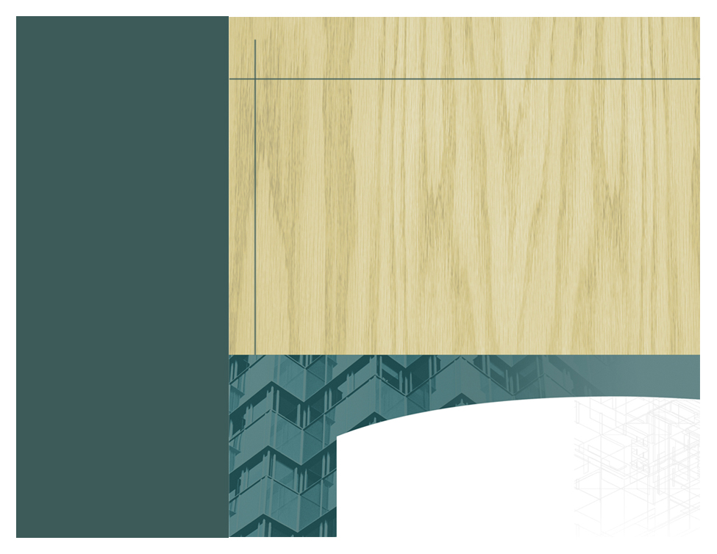<EMPTY><EMPTY>

* Are you willing to take on all the responsibilities of a contractor?
* Are you willing to provide direct, onsite supervision of the construction?
* Are you willing to call for inspections to ensure all work meets proper building codes?
* Are you willing to be held accountable if shoddy work is performed or inspections failed?
* Are you willing to withhold employment taxes and provide workers compensation coverage?
* Are you willing to ensure the safety of individuals working on your property?
* Are you willing to be held liable if work causes damage to your neighbor’s property?
* Do you know the basic principles of residential construction?

The Mississippi State Board of Contractors recommends that ONLY homeowners with significant experience and skill renovating or building homes and up to date knowledge of building codes pull their own permits. Otherwise, hire a licensed contractor.

For most individuals, a home is the most valuable asset. In order to protect yourself and your investment, please consider the following before pulling your own building permit:

**WHAT TO CONSIDER BEFORE PULLING YOUR OWN PERMIT**



2679 Crane Ridge Drive, Suite C

Jackson, MS 39216

**Ph** (800) 880 6161

**Fx** (601) 354 6715

www.msboc.us

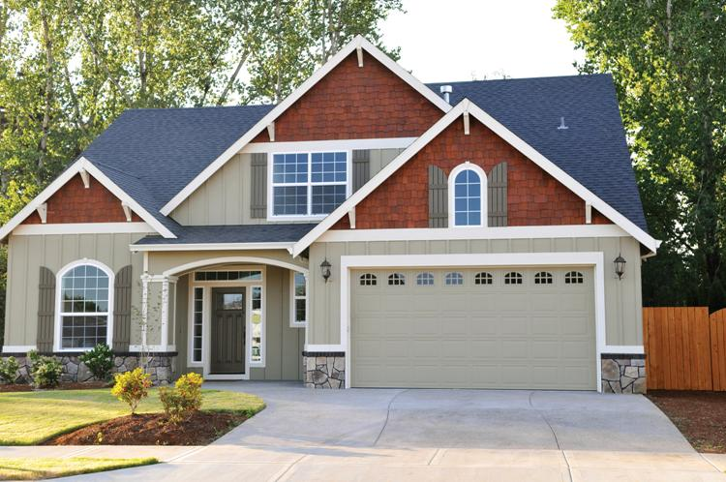

HOMEOWNERS…Pulling your own permit is RISKY BUSINESS!

If you do not intend to do the work yourself and have been asked by someone without a contractor’s license to pull a permit, you are at risk of financial harm.

Fraudulent contractors like to fool people. That’s how they earn a living. They will tell you, “Don’t worry, you don’t need a permit, I’ve been doing this for years” or “Don’t worry, I am licensed and bonded.” Demand WRITTEN PROOF of their claims because YOU will pay the price if something goes wrong.

Protect yourself. Hire only licensed contractors. For more information or to verify whether a contractor is licensed visit our website at [www.msboc.us](http://www.msboc.us) or contact us directly at 1-800-880-6161.

.

[**www.web address**](http://www.webaddress) **here**

DELETE BOX, OR PLACE TEXT OR LOGO HERE

**Ph 555.555.5555 Fx** 555.555.5555

**5555 Street Address City, US, 55555**

**www.webaddress.com**

*Delete box or place a tag line or quote here. Delete box or place a tag line or quote here. Delete box or place a tag line or quote here. Delete box or place a tag line or quote here.*